**Count the Dots—*Binary Numbers***

**Summary**

Data in computers is stored and transmitted as a series of zeros and ones. How can we represent words and numbers using just these two symbols?

All cards in the set will need to be punched into brail or be raised. The demonstration will need to be either individual. Morse code with binary is another idea.

**Curriculum Links**

9 Mathematics: Number Level 2 and up. Exploring numbers in other bases.

Representing numbers in base two.

9 Mathematics: Algebra Level 2 and up. Continue a sequential pattern, and describe a rule for this pattern. Patterns and relationships in powers of two.

**Skills**

9 Counting

9 Matching

9 Sequencing

**Ages**

9 7 and up

**Materials**

9 You will need to make a set of five binary cards (see page 6) for the demonstration.

A4 cards with smiley face sticker dots work well. Each child will need:

9 A set of five cards.

Copy Photocopy Master: Binary numbers (page 6) onto card and cut out.

9 Worksheet Activity: Binary numbers (page 5)

There are optional extension activities, for which each child will need:

9 Worksheet Activity: Working with binary (page 7)

9 Worksheet Activity: Sending secret messages (page 8)

9 Worksheet Activity: Fax machines and modems (page 9)

9 Worksheet Activity: Counting higher than 31 (page 10)

9 Worksheet Activity: More on binary numbers (page 11)

Worksheets will all need to made into digital copies.

*Photocopiable for classroom use only.* 3

*© 2002 Computer Science Unplugged (www.unplugged.canterbury.ac.nz)*

For this section the cards will need to be punched or have raised dots. Also, a class

demonstration will need to be reworked or removed.

Again this is going to need to be some sort of small group or individual demonstration with punched cards or cards with raised dots.

**Introduction**

Before giving out the worksheet on page 5, it can be helpful to demonstrate the principles to the whole group.

For this activity, you will need a set of five cards, as shown below, with dots on one side and nothing on the other. Choose five children to hold the demonstration cards at the front of the class. The cards should be in the following order:

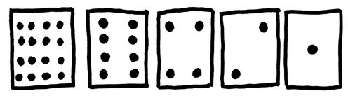

**Discussion**

What do you notice about the number of dots on the cards? (Each card has twice as many as the card to its right.)

How many dots would the next card have if we carried on to the left? (32) The next…? We can use these cards to make numbers by turning some of them face down and adding

up the dots that are showing. Ask the children to make 6 (4-dot and 2-dot cards), then 15

(8-, 4-, 2- and 1-dot cards), then 21 (16, 4 and 1)… Now try counting from zero onwards.

The rest of the class needs to look closely at how the cards change to see if they can see a pattern in how the cards flip (each card flips half as often as the one to its right). You may like to try this with more than one group.

When a binary number card is **not** showing, it is represented by a zero. When it **is**

showing, it is represented by a one. This is the binary number system.

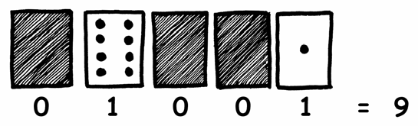

Ask the children to make 01001. What number is this in decimal? (9) What would 17 be in binary? (10001)

Try a few more until they understand the concept.

There are five optional follow-up extension activities, to be used for reinforcement. The children should do as many of them as they can.

4 *Photocopiable for classroom use only.*

*© 2005 Computer Science Unplugged (www.unplugged.canterbury.ac.nz)*

Worksheet Activity: Binary Numbers

Learning how to count

So, you thought you knew how to count? Well, here is a new way to do it!

Did you know that computers use only zero and one? Everything that you see or hear on the computer—words, pictures, numbers, movies and even sound is stored using just those two numbers! These activities will teach you how to send secret messages to your friends using exactly the same method as a computer.

Instructions

Cut out the cards on your sheet and lay them out with the 16-dot card on the left as shown here:

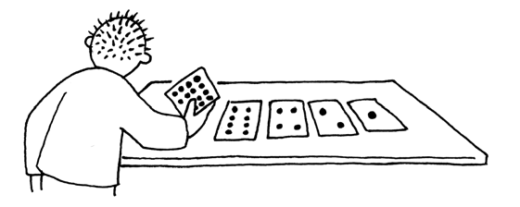

Make sure the cards are placed in exactly the same order.

Now flip the cards so exactly 5 dots show—keep your cards in the same order!

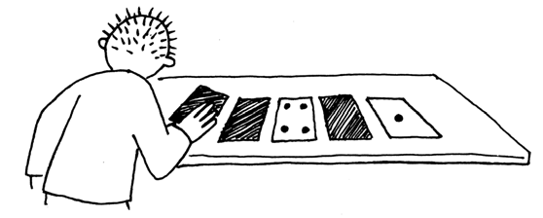

Find out how to get 3, 12, 19. Is there more than one way to get any number? What is the biggest number you can make? What is the smallest? Is there any number you can’t make between the smallest and biggest numbers?

**Extra for Experts:** Try making the numbers 1, 2, 3, 4 in order. Can you work out a logical and reliable method of flipping the cards to increase any number by one?

*Photocopiable for classroom use only.* 5

*© 2002 Computer Science Unplugged (www.unplugged.canterbury.ac.nz)*

**Photocopy Master: Binary Numbers**

•••• • •

• • •

•

•••• • • • • •

•••• • •

• • •

•

•••• • • • • •

•••• • •

• • •

•

•••• • • • • •

•••• • •

• • •

•

•••• • • • • •

6 *Photocopiable for classroom use only.*

© *2005 Computer Science Unplugged {www.unplugged.canterbury.ac.nz)*

Worksheet Activity: Working With Binary

The binary system uses **zero** and **one** to represent whether a card is face up or not. **0** shows that a card is hidden, and **1** means that you can see the dots. For example:

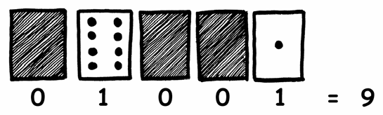

Can you work out what **10101** is? What about **11111**?

What day of the month were you born? Write it in binary. Find out what your friend’s birthdays are in binary.

Try to work out these coded numbers:

Because this is using pictures and imagery to symbolize 1's and

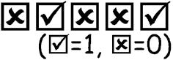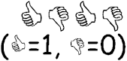

0's, this could either be turned into some sort of digital document to be read in 1's and 0's by a screen reader, or it can be a series of raised dots, or

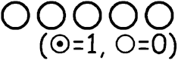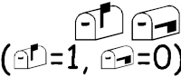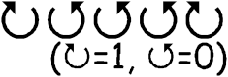

maybe even a series of morse code beeps (short for 0 and long for 1). OR, we can mix and match to get something fun.

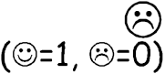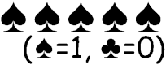

**Extra for Experts:** Using a set of rods of length 1, 2, 4, 8 and 16 units show how you can make any length up to 31 units. Or you could surprise an adult and show them

how they only need a balance scale and a few weights to be able to weigh those heavy things like suitcases or boxes!

*Photocopiable for classroom use only.* 7

*© 2002 Computer Science Unplugged (www.unplugged.canterbury.ac.nz)*

Worksheet Activity: Sending Secret Messages

Very similar to the last activity. Each row can be a series of raised and punched dots on a piece of paper, a series of beeps, or a series of 0's and 1's document for a

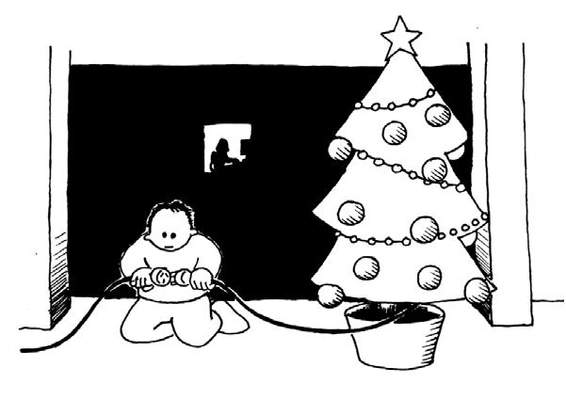

screen reader with the code readily available for the kids to use.

Tom is trapped on the top floor of a department store. It’s just before Christmas and he wants to get home with his presents. What can he do? He has tried calling, even yelling, but there is no one around. Across the street he can see some computer person still working away late into the night. How could he

attract her attention? Tom looks around to see what he could use. Then he has a brilliant idea—he can use the Christmas tree lights to send her a message! He finds all the lights and plugs them in so he can turn them on and off. He uses a simple binary code, which he knows the woman across the street is sure to understand. Can you work it out?

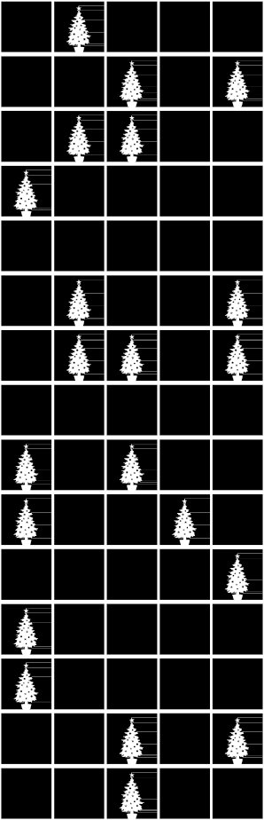

|  |  |  |  |  |  |  |  |  |  |  |  |  |
| --- | --- | --- | --- | --- | --- | --- | --- | --- | --- | --- | --- | --- |
| 1 | 2 | 3 | 4 | 5 | 6 | 7 | 8 | 9 | 10 | 11 | 12 | 13 |
| a | b | c | d | e | f | g | h | i | j | k | l | m |
| 14 | 15 | 16 | 17 | 18 | 19 | 20 | 21 | 22 | 23 | 24 | 25 | 26 |
| n | o | p | q | r | s | t | u | v | w | x | y | z |

8 *Photocopiable for classroom use only.*

*© 2005 Computer Science Unplugged (www.unplugged.canterbury.ac.nz)*

Worksheet Activity: E-mail and Modems

This is just a create your own activity using the key and method (most likely 1's and 0's on individual lines for a document) from the last activity

Computers connected to the internet through a modem also use the binary system to send messages. The only difference is that they use beeps. A high- pitched beep is used for a one and a low-pitched beep is used for a zero. These tones go very fast—so fast, in fact, that all we can hear is a horrible continuous screeching sound. If you have never heard it, listen to a modem connecting to the Internet, or try calling a fax machine—fax machines also use modems to send information.

Using the same code that Tom used in the department store, try sending an e- mail message to your friend. Make it easy for yourself and your friend though— you don’t have to be as fast as a real modem!

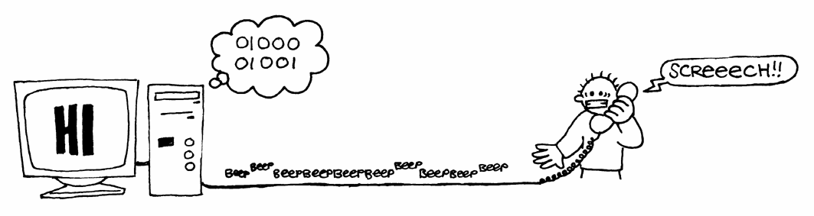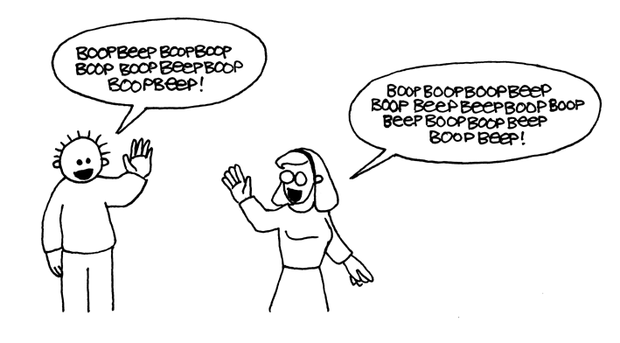

*Photocopiable for classroom use only.* 9

*© 2002 Computer Science Unplugged (www.unplugged.canterbury.ac.nz)*

sequence, how many dots would it have? What about the next card after that? What is the rule that you are following to make your new cards? As you can see, only a few cards are needed to count up to very big numbers.

If you look at the sequence carefully, you can find a very interesting relationship:

This activity is solid, with a simple question down at the

bottom. 1,048,576 (including 0!)

1, 2, 4, 8, 16…

Try adding: 1 + 2 + 4 = ? What does it come to? Now try 1 + 2 + 4 + 8 = ?

What happens if you add all the numbers up from the beginning?

Have you ever heard of “let your fingers do the walking”? Well now you can let your fingers do the counting, but you can get much higher than ten—no, you don’t have to be an alien! If you use the binary system and let each finger on one hand represent one of the cards with dots you can count from 0–31. That’s

32 numbers. (Don’t forget that zero is a number too!)

Try counting in order using your fingers. If a finger is up it is a one, and if it is down it is a zero.

You can actually get from 0–1023 if you use both hands! That’s 1024 numbers! If you had really bendy toes (now you would have to be an alien) you could get

even higher. If one hand can be used to count 32 numbers, and two hands can

count to 32 × 32 = 1024 numbers, what is the biggest number Miss Flexi-Toes can reach?

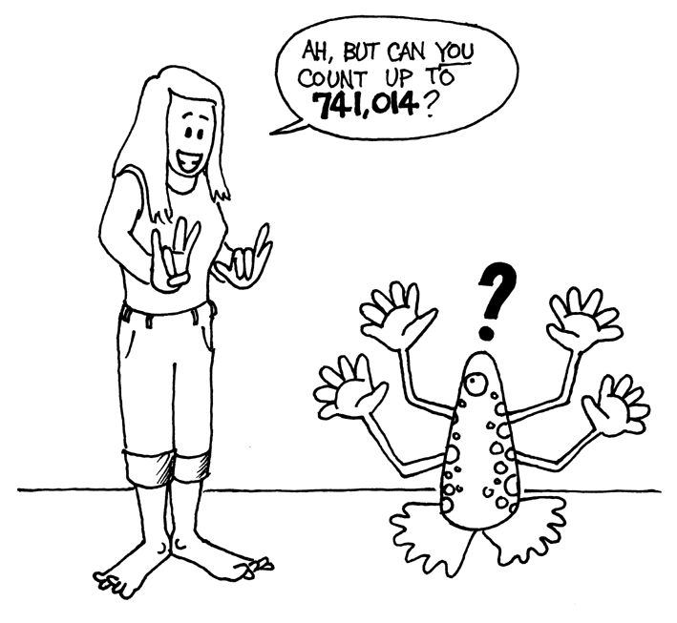

10 *Photocopiable for classroom use only.*

*© 2005 Computer Science Unplugged (www.unplugged.canterbury.ac.nz)*

put on the right hand side of the number. If we are working in base 10 (decimal), when you put a zero on the right hand side of the number, it is multiplied by 10. For example, 9 becomes 90, 30 becomes 300.

But what happens when you put a 0 on the right of a binary number? Try this:

1001 o 10010

(9) (?)

Make up some others to test your hypothesis. What is the rule? Why do you think this happens?

Instead of going to look at a keyboard,

2. Each of the cards we have used so far represents a ‘bit’ on the computer (‘bit’ is short for ‘**b**inary dig**it**’). So our alphabet code we have used so far can be represented using just five cards, or ‘bits’. However a computer has to know whether letters are capitals or not, and also recognise digits, punctuation and

this may have to turn

into something like an internet search for how many characters are accessible

through a keyboard. (and we need to mention that they should only look at

the ASCII characters)

special symbols such as **$** or **~**.

Go and look at a keyboard and work out how many characters a computer has to represent. So how many bits does a computer need to store all the characters?

Most computers today use a representation called ASCII (**A**merican **S**tandard **C**ode for **I**nformation **I**nterchange), which is based on using this number of bits per character, but some non-English speaking countries have to use longer codes.

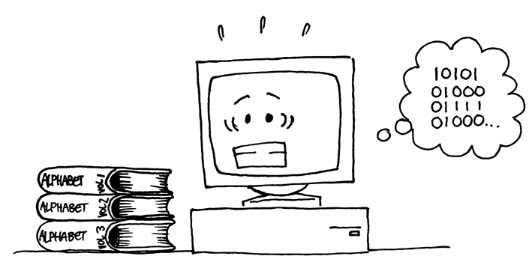

*Photocopiable for classroom use only.* 11

*© 2002 Computer Science Unplugged (www.unplugged.canterbury.ac.nz)*

Computers today use the binary system to represent information. It is called binary because only two different digits are used. It is also known as base two (humans normally use base 10). Each zero or one is called a *bit* (**b**inary dig**it**). A bit is usually represented in a computer’s main memory by a transistor that is switched on or off, or a capacitor that is charged or discharged.

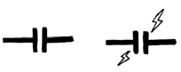

When data must be transmitted over a telephone line or radio link, high and low-pitched tones are used for the ones and zeros. On magnetic disks (floppy disks and hard disks) and tapes, bits are represented by the direction of a magnetic field on a coated surface, either North-South or South-North.

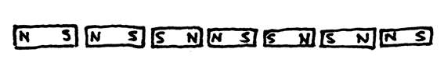

Great/interesting information!

Audio CDs, CD-ROMs and DVDs store bits optically—the part of the surface corresponding to a bit either does or does not reflect light.

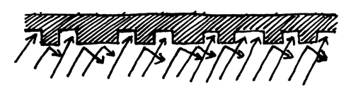

One bit on its own can’t represent much, so they are usually grouped together in groups of eight, which can represent numbers from 0 to 255. A group of eight bits is called a byte.

The speed of a computer depends on the number of bits it can process at once. For example, a 32-bit computer can process 32-bit numbers in one operation, while a 16-bit computer must break 32-bit numbers down into smaller pieces, making it slower.

Ultimately bits and bytes are all that a computer uses to store and transmit numbers, text, and all other information. In some of the later activities we will see how other kinds of information can be represented on a computer.

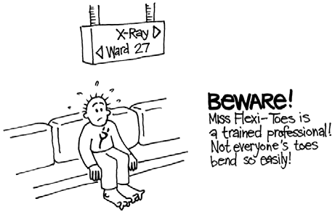

12 *Photocopiable for classroom use only.*

*© 2005 Computer Science Unplugged (www.unplugged.canterbury.ac.nz)*

**Binary Numbers** (page 5)

**3** requires cards 2 and 1

**12** requires cards 8 and 4

**19** requires cards 16, 2 and 1

There is only one way to make any number.

The biggest number you can make is 31. The smallest is 0. You can make every number in between, and each has a unique representation.

**Experts:** To increase any number by one, flip all the cards from right to left until you turn one face up.

**Working with binary** (page 7)

10101 = 21, 11111 = 31

**Sending Secret Messages** (page 8) Coded message: HELP IM TRAPPED **Counting higher than 31** (page 10)

If you add the numbers up from the beginning the sum will always be one less than the

next number in the sequence.

Miss Flexi-toes can count 1024 × 1024 = 1,048,576 numbers—from 0 to 1,048,575!

**More on Binary Numbers** (page 11)

When you put a zero on the right hand side of a binary number the number doubles.

All of the places containing a one are now worth twice their previous value, and so the total number doubles. (In base 10 adding a zero to the right multiplies it by 10.)

A computer needs 7 bits to store all the characters. This allows for up to 128 characters. Usually the 7 bits are stored in an 8-bit byte, with one bit wasted.

*Photocopiable for classroom use only.* 13

*© 2002 Computer Science Unplugged (www.unplugged.canterbury.ac.nz)*